**Download and Configure the Apache Tomcat:**

1. Check the latest version of Apache Tomcat
2. Get the downloadable link of latest stable version
3. Use below command to download same in Linux
4. https://archive.apache.org/dist/tomcat/tomcat-10/v10.1.35/bin/

wget <https://archive.apache.org/dist/tomcat/tomcat-10/v10.1.33/bin/apache-tomcat-10.1.33.zip>

1. Unzip the downloaded file with below command

unzip apache-tomcat-10.1.33.zip

1. Go to below directory and remove unwanted applications from webapps

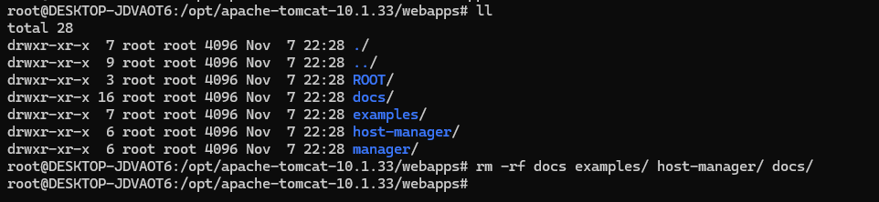

In the above screenshot we have removed ROOT, examples and host-manager

1. To change to port number please follow the below steps
2. Go to path $TOMCAT_HOME/conf/
3. Open server.xml file and change the value of default to port you want configure

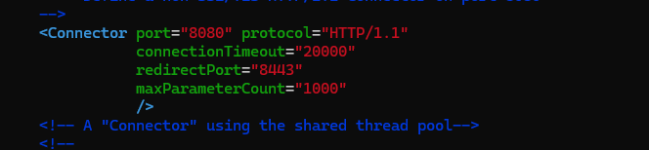

1. Default Apache Home Page showing

Replace the index.jsp file from below path to custom home page/ error page that will display when we access the domain URL of our application

$TOMCAT_HOME/webapps/ROOT

1. Change the session timeout for inactivity from application side. Default value is 30 minutes

$TOMCAT_HOME /conf/web.xml

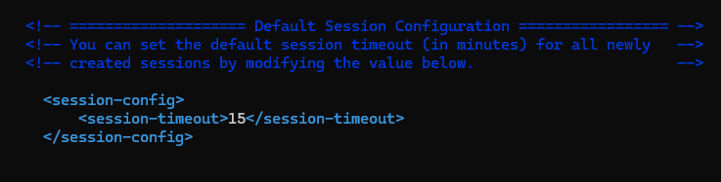

1. To enable HSTS headers to add the below configuration in / Missing Security Headers

$TOMCAT_HOME /conf/web.xml

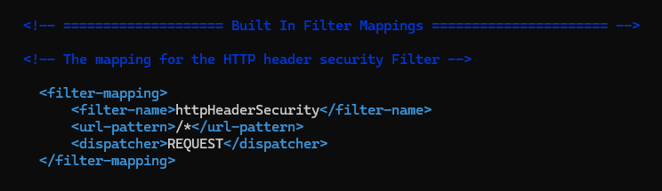

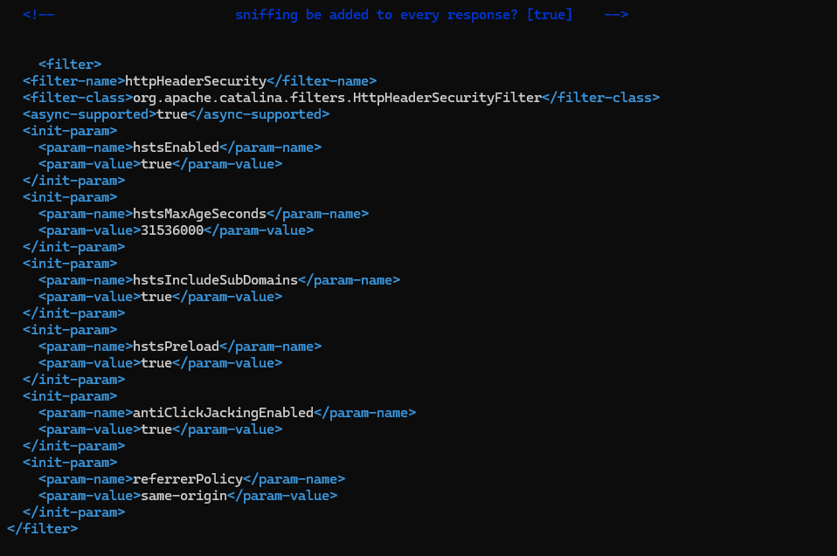

1. Configure User credentials and Roles for Manager Page

Go to path $TOMCAT_HOME/conf/tomcat-users.xml

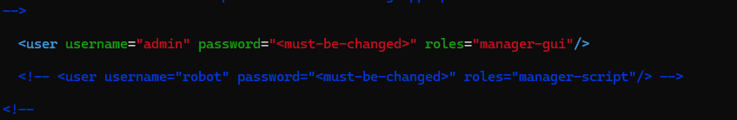

KotakMLOS/ M0b1cu!e123 and **Role** – “manager-gui”

1. Manager Page URL

**Local:**

<http://localhost:8888/manager/html>

Domain:

<https://domain.com/manager/html>

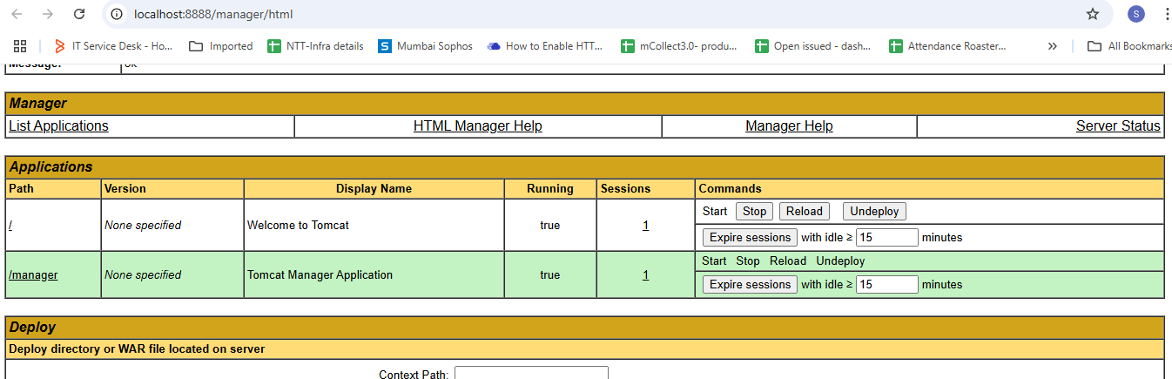

1. Change the default Error Pages: Add the below tags in web.xml file

$TOMCAT_HOME /conf/web.xml

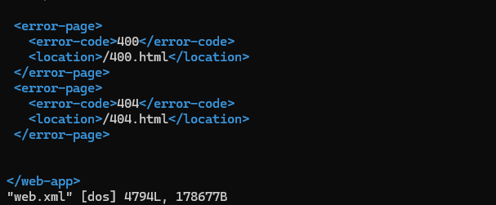

1. Change the default error pages (401.jsp, 403.jsp, 404.jsp) from manager on path $TOMCAT_HOME/webapps/manager/WEB-INF/jsp
2. Redirecting to 400 bad request custom error page – Add the below configuration

$TOMCAT_HOME /conf/server.xml

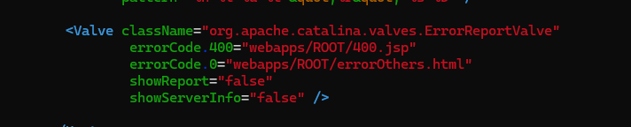

<Valve className="org.apache.catalina.valves.ErrorReportValve"

errorCode.400="webapps/ROOT/400.jsp"

errorCode.0="webapps/ROOT/errorOthers.html"

showReport="false"

showServerInfo="false" />

1. Disable Catalina.out logs

Edit "$CATALINA_BASE"/bin/catalina.sh file

Find CATALINA_OUT="$CATALINA_BASE"/logs/catalina.out

Replace with new path.

Restart tomcat.

And as suggested in comments, to block writing to catalina.out entirely, **set CATALINA_OUT=/dev/null in catalina.sh**

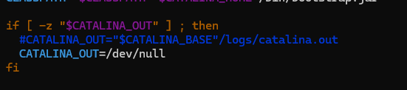

1. Tomcat Version Disclosure

Open Server .xml from path $TOMCAT_HOME /conf/server.xml

Find the Host section and add the below line immediately after it:

<Valve className="org.apache.catalina.valves.ErrorReportValve" showReport="false" showServerInfo="false" />

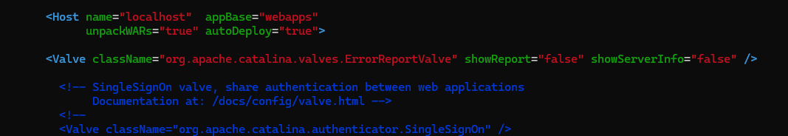

1. Restrict HTTP methods

Add the tags below in web.xml file

$TOMCAT_HOME /conf/web.xml

<security-constraint>  
    <web-resource-collection>  
      <web-resource-name>restricted methods</web-resource-name>  
      <url-pattern>/*</url-pattern>         
      <http-method>OPTIONS</http-method>  
      <http-method>DELETE</http-method>  
    </web-resource-collection>  
    <auth-constraint/>  
  </security-constraint>

